



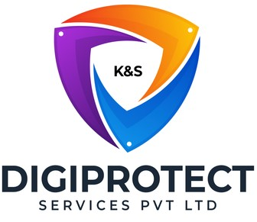

INITIAL
ASSESSMENT
REPORT

DATE: 28th June 2024
Risk

VERSION: 1.1

Document History
Document version | Remarks | Submitted  By | Submission  Date | Approved BY | Approval  Date
1.0 | First Draft | k&S Digiprotect | 11th June 2024
1.1 | Second Draft | k&S Digiprotect | 28th June 2024

K&S Digiprotect Services Pvt. Ltd.
Date of Discussion: Date of Release:
Version: 1.0
Date of Release: 15th April 2024

Table of Contents
Introduction 4
Objectives 4
General Information 5
SPOC Information 5
Department Hierarchy* 6
Observations 7
Data Flow Diagram (DFD) 12
Data Mapping and Inventory 13
Recommendations 14
Conclusion 14
Appendices 15
Appendix A 15

Introduction
India Shelter’s Risk department plays a key role in protecting the company’s reputation and enhancing stakeholder confidence. They employ a comprehensive and proactive approach to risk management, integrating analytical tools, industry best practices, and regulatory frameworks. By fostering a culture of risk awareness and resilience, they empower ISFC’s internal teams to navigate the complex and dynamic financial landscape effectively.
This report encapsulates critical insights for As-Is study, derived from the initial interview conducted with the Risk Department of India Shelter Finance Corporation Limited (ISFC) for the implementation of ISO/IEC 27001:2022 and compliance with the Digital Personal Data Protection Act (DPDPA).
The overarching objectives of this interview were dual fold: first, to gain an understanding of the departmental structure, and second, to delve into the core operational processes of the Risk Department. Additionally, the interview aimed to assess the existing information security practices, focusing on evaluating adherence to DPDPA requirements and the readiness for ISO/IEC 27001:2022 implementation.
By delving into the details of the department's organizational setup, operational workflows, and data handling procedures, this report aims to identify both the strengths and areas of improvement in information security management and DPDPA compliance within the department.

Objectives
- Understand the departmental hierarchy and reporting structure
- Learn the existing processes of ISFC’s Risk Department
- Mapping of existing processes with documented processes
- Offer recommendations to optimize the existing processes

General Information
Organization Name | India Shelter Finance Corporation Limited
Department Name | Risk Department
Date of the Assessment | 5th April 2024
Location | 6th Floor, India Shelter HQ, Gurugram
Meeting Duration | 45 minutes
Attendees (ISFC) | Sharad Pareek, Rashmi Choudhary, Dheeraj Yadav, Sunil Kumar Sharma
Attendees (Digiprotect) | Lalit Mohan Joshi, Sushil Menon, Adhita Razdan

SPOC Information
Project SPOC: Dheeraj Yadav
Contact Information:
Email ID: dheeraj.yadav@indiashelter.in

Project Coordinator: Sunil Kumar Sharma
Contact Information:
Email ID: sunil.sharma2@indiashelter.in

Department SPOC: Rashmi Choudhary
Contact Information:
Email ID: rashmi.choudhary@indiashelter.in

Department Hierarchy*

* As informed during the meeting

Observations
S. No | Key Activities | Observations and Asks | Remarks
 | Risk Department:  - The department, headed by the CRO, is responsible for implementing the Risk - management framework across the organization.  - They gather information from various departments to consolidate risks and communicate the overall risk profile (enterprise risk management - ERM) of the company.  - The department reviews and adapts the company's risk mitigation strategies, considering the overall risk appetite.  - Processes to identify and evaluate business areas using risk control self-assessments are developed and managed by the department.  - They also monitor risk exposure and internal control lapses, reporting pertinent information to the Risk Management Committee.  - The department ensures that strategies approved by the Risk Management Committee are implemented. | - Risk department has a Salesforce account for training purpose. | - ISFC to confirm that the risk department does not have a Salesforce account. - Updated and added to Observations and Asks
Risk Governance Framework:
- The Board of Directors reviews and approves the risk appetite and strategic plans for risk management annually.
- The Board establishes a management structure capable of implementing the company’s Risk Management Framework.
- Policies and procedures around risk management are developed, consistent with the organization’s strategy and risk appetite.
- Steps are taken to foster risk awareness and promote an organizational culture of identifying risk in the business processes.
- Any matter requiring the Board’s approval is addressed in a timely manner.
Risk Management Committee (RMC):
- The RMC reviews compliance with risk policies, methodologies, and tools, including assessments and reporting systems.
- They monitor breaches or triggers of risk tolerance limits and recommend corrective actions as necessary.
- Reports of significant issues are reviewed, including risk exposure related to specific issues, concentrations, and limit excesses.
- The RMC nurtures an independent risk management function and fosters a risk-aware culture within the organization.
- Risk Management framework and policy are established by the RMC and approved by the Board.
- The RMC assesses and reports on reputational, governance, business, and strategic risks, and manages potential risks arising from regulatory changes or shifts in the economic/political environment.
Asset Liability Management Committee (ALCO):
- ALCO manages tasks and responsibilities as per the authority delegated by the Board of Directors.
- They periodically review and approve strategies to manage liquidity and interest rate risks.
- The committee ensures compliance with the ALCO policy and the overall risk management framework.
- Regular monitoring and evaluation of asset and liability management strategies are conducted by ALCO.
- ALCO reviews derivative transactions and ensures they are used solely for hedging identified exposures, not speculation.
- Periodic reviews of ALCO activities are undertaken to ensure adherence to policies and effective risk management.
Audit Committee:
- The Audit Committee evaluates internal financial controls and risk management systems on a quarterly basis.
- Operational risks are identified and presented during regular internal audits.
- The internal audit focuses on significant risks and audits the risk management processes across the organization.
- Controls and risk response plans are evaluated for significant risks, and corrective actions are enforced where necessary.
- The effectiveness of risk management practices is independently reviewed by the Audit Committee.
- The Audit Committee ensures that the risk management process is functioning as designed and achieving its objectives.
Risk Management Strategy:
- Guidelines for responding to various business risks are laid down by the company.
- Mitigation strategies are formulated and periodically reviewed to ensure they remain effective.
- Risks are identified, assessed, and prioritized using quantitative, semi-quantitative, or qualitative techniques.
- Relevant strategies or tools are identified to effectively mitigate possible risk events.
- The company ensures that risk mitigation transactions, such as derivatives, are reviewed quarterly by ALCO.
- Periodic reviews are conducted to ensure the continued effectiveness of risk management strategies and tools.
Three Lines of Defence Model:
- The first line of defence - Business Units identifies, manages, mitigates, and reports on risks.
- The second line of defence - Compliance & Risk Management Department, independently monitors and maintains policies and procedures.
- The third line of defence – Internal Audit validates the overall risk, compliance, and control framework.
Risk Categories Overview:
- The primary risk categories include credit risk, operational risk, market risk, liquidity risk, interest rate risk, foreign exchange risk, strategic risk, reputation risk, compliance risk, and legal risk.
- Each risk type is identified, assessed, and managed according to specific guidelines and mitigation strategies outlined in the organization's risk management framework.
- The risk management strategy includes measures to minimize potential losses and ensure that the organization remains within its risk tolerance limits.

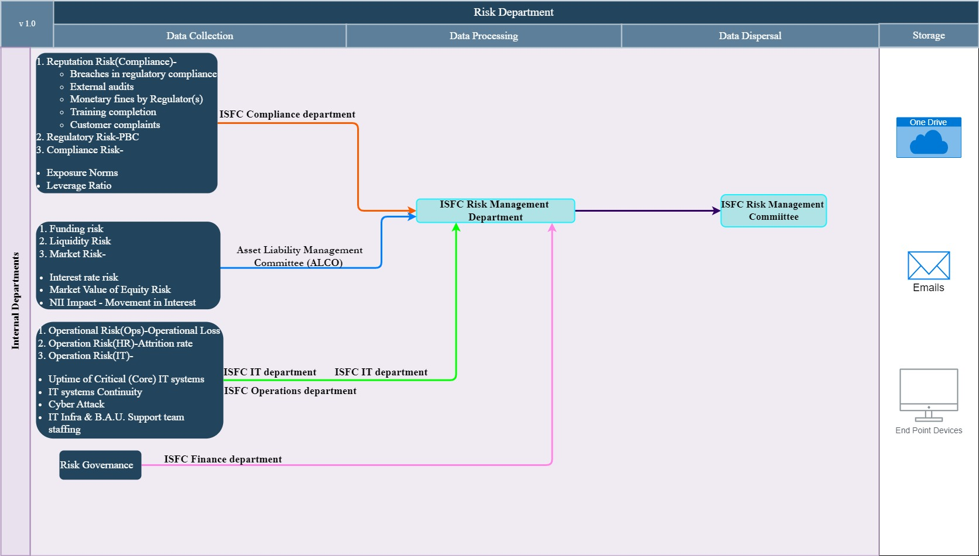
Data Flow Diagram (DFD)

Data Mapping and Inventory
S. No | Data Category | Description | Purpose | Data Owner | Storage Location | Data Classification* | Retention Period | Legal Basis
1. | Risk Monitoring Reports | Monitoring of risk exposure and internal control lapses | To report pertinent information to the Risk Management Committee | Risk Department | One Drive/ Excel | Non PII/ Confidential | Not Defined | Legitimate Interest

*Refer Appendix A

Recommendations
- Integration of Information Security and Data privacy risks into the current risk management framework
  - ISFC must consider including information security, and data privacy risks into the current risk register to enhance their security posture.

Conclusion
The risk department of ISFC plays a vital role in enabling the company to be financially stable, comply with regulatory, and statutory requirements. The risk department acts as a guardian, identifying, analysing, and mitigating risks.
Key Functions:
Risk Management Committee (RMC):
- The RMC reviews and approves compliance with risk policies, methodologies, and tools, including assessments and reporting systems.
- A Risk Management framework and policy are established and recommended to the Board for approval.
- The RMC assesses and reports on reputational, governance, business, and strategic risks, and manages potential risks arising from regulatory changes or shifts in the economic/political environment
Asset Liability Management Committee (ALCO):
- ALCO manages tasks and responsibilities as per the authority delegated by the Board of Directors.
- ALCO periodically reviews and approves strategies to manage liquidity and interest rate risks.
- Regular monitoring and evaluation of asset and liability management strategies are conducted by ALCO.
Audit Committee:
- The Audit Committee evaluates internal financial controls and risk management systems on a quarterly basis.
Three Lines of Defence Model:
- The first line of defence - Business Units identifies, manages, mitigates, and reports on risks.
- The second line of defence - Compliance & Risk Management Department, independently monitors and maintains policies and procedures.
- The third line of defence – Internal Audit validates the overall risk, compliance, and control framework.
Risk Department:
- The Department, headed by the CRO, is responsible for implementing the Risk Management framework across the organization.
- They review and adjust the company's risk exposure strategies, considering the overall risk appetite.
- The Department reports important information to the Risk Management Committee.
An effective Risk department allows ISFC to make informed lending decisions, manage resources efficiently, and navigate a dynamic financial landscape.

Appendices

Appendix A
Data Classification | Definition
Sensitive Data | Information that, if disclosed, altered, or destroyed without authorization, could cause significant harm to an individual, organization, or entity. This often includes financial records, medical information, and PII.
Restricted Data | Highly sensitive data tightly controlled due to legal, regulatory, or contractual requirements. Access is limited to authorized personnel, and any unauthorized disclosure may result in severe consequences.
Private Data | Information considered confidential and intended solely for specific individuals or groups within an organization. It requires protection from unauthorized access to maintain privacy and uphold confidentiality agreements.
Confidential Data | Privileged or proprietary information of an organization requiring protection from unauthorized access, disclosure, or alteration.
Public Data | Information that is freely available and accessible to the general public without restrictions or limitations. It does not contain sensitive or confidential information and can be openly accessed and used for various purposes such as research, analysis, and public interest initiatives.
PII (Personally Identifiable Information) | Data that can identify, contact, or locate an individual, either alone or in combination with other information. For example - names, addresses, official identifiers (Aadhar, Pan, DL, biometrics, etc).
Non-PII | Data that, while not personally identifiable, however may still require protection due to its sensitivity or confidentiality. This may include corporate financial information, proprietary research data, or internal communications.

-------------------------------------------End of report for Risk------------------------------

